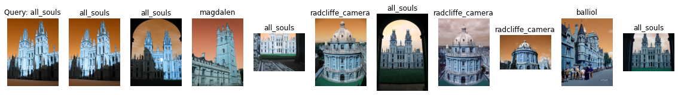

Label: all_souls

Average Precision for query 0: 0.3354503348528164

Precision@k for query 0: 0.5

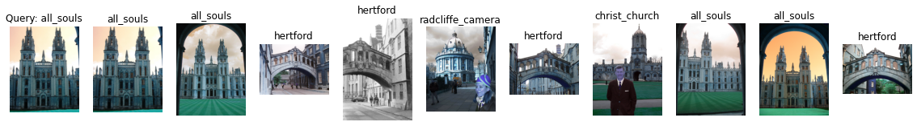

Label: all_souls

Average Precision for query 1: 0.25565574759360504

Precision@k for query 1: 0.4

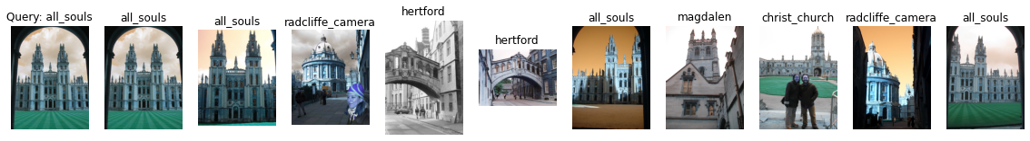

Label: all_souls

Average Precision for query 2: 0.2653834215526174

Precision@k for query 2: 0.4



Label: all_souls

Average Precision for query 3: 0.5832789210158048

Precision@k for query 3: 1.0

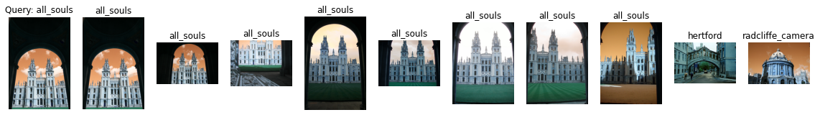

Label: all_souls

Average Precision for query 4: 0.4094549131131613

Precision@k for query 4: 0.8



Label: ashmolean

Average Precision for query 5: 0.3142042128057567

Precision@k for query 5: 0.6

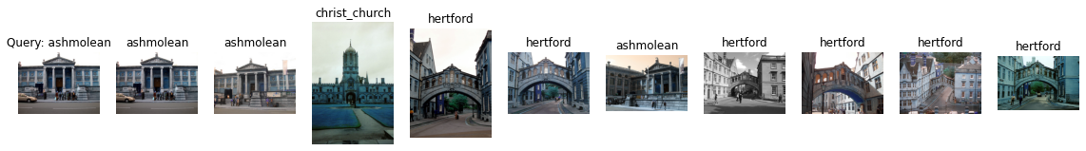

Label: ashmolean

Average Precision for query 6: 0.15103140678461996

Precision@k for query 6: 0.3

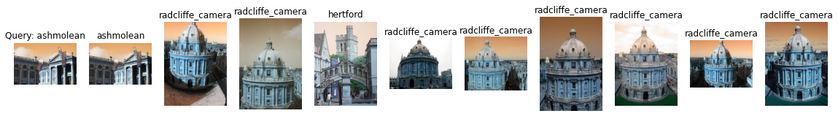

Label: ashmolean

Average Precision for query 7: 0.06985952976212069

Precision@k for query 7: 0.1

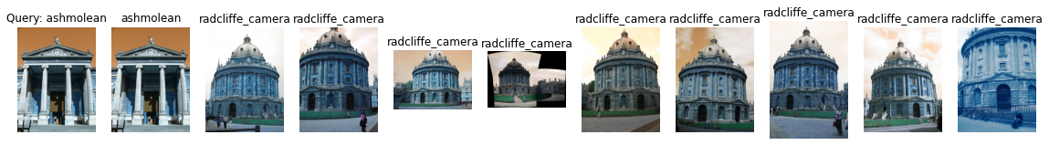

Label: ashmolean

Average Precision for query 8: 0.1076035725239335

Precision@k for query 8: 0.1

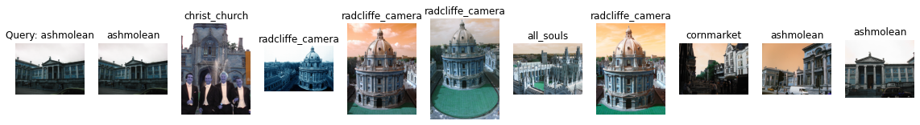

Label: ashmolean

Average Precision for query 9: 0.12011479325100316

Precision@k for query 9: 0.3

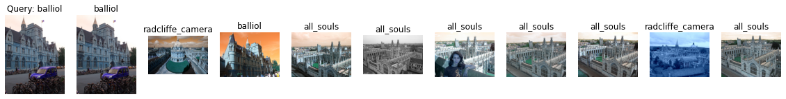

Label: balliol

Average Precision for query 10: 0.20704807007811796

Precision@k for query 10: 0.2

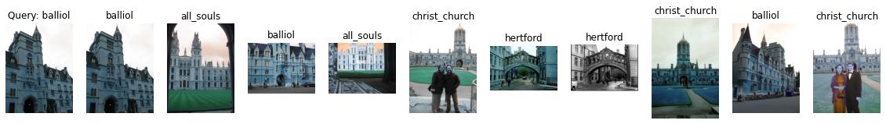

Label: balliol

Average Precision for query 11: 0.26260781809416384

Precision@k for query 11: 0.3



Label: balliol

Average Precision for query 12: 0.27917634143476067

Precision@k for query 12: 0.3

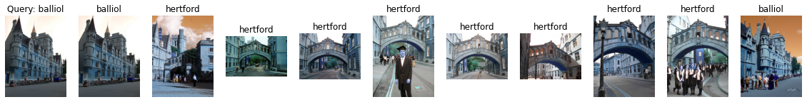

Label: balliol

Average Precision for query 13: 0.18540713135327236

Precision@k for query 13: 0.2

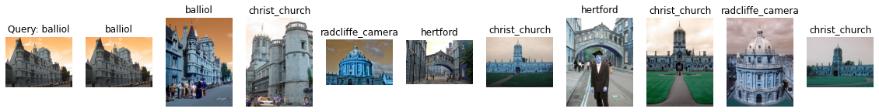

Label: balliol

Average Precision for query 14: 0.24523916381724364

Precision@k for query 14: 0.2

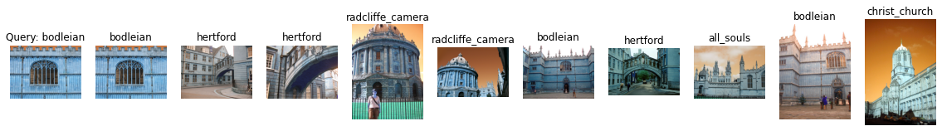

Label: bodleian

Average Precision for query 15: 0.20316648709100518

Precision@k for query 15: 0.3

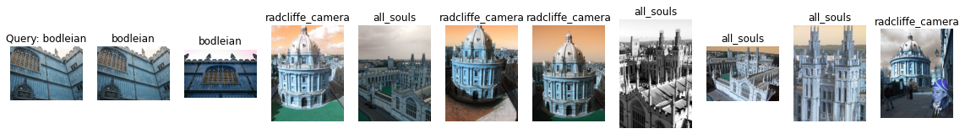

Label: bodleian

Average Precision for query 16: 0.12311662205629971

Precision@k for query 16: 0.2

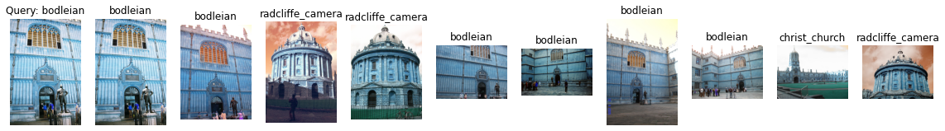

Label: bodleian

Average Precision for query 17: 0.29093212610522007

Precision@k for query 17: 0.6



Label: bodleian

Average Precision for query 18: 0.13842854625174253

Precision@k for query 18: 0.3

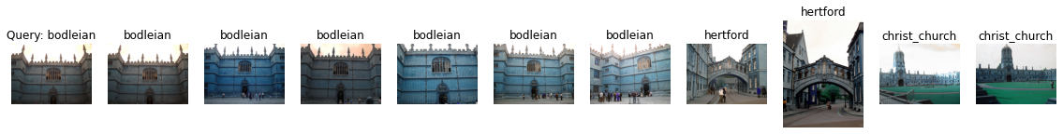

Label: bodleian

Average Precision for query 19: 0.39745328264260166

Precision@k for query 19: 0.6

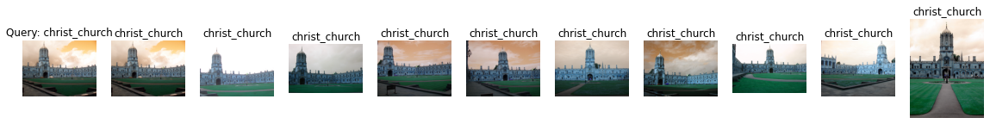

Label: christ_church

Average Precision for query 20: 0.3921640853300937

Precision@k for query 20: 1.0



Label: christ_church

Average Precision for query 21: 0.54788116673439

Precision@k for query 21: 1.0

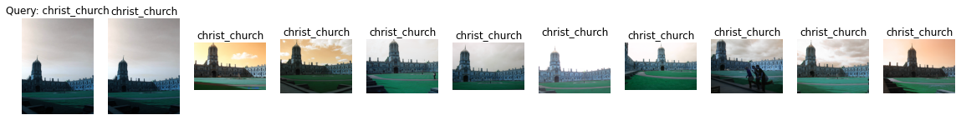

Label: christ_church

Average Precision for query 22: 0.4892661764411372

Precision@k for query 22: 1.0

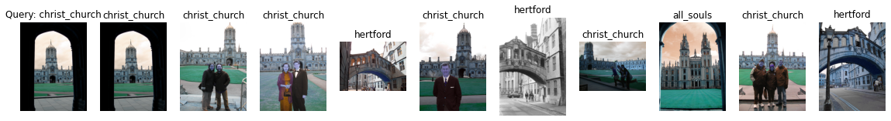

Label: christ_church

Average Precision for query 23: 0.2826327363002611

Precision@k for query 23: 0.6



Label: christ_church

Average Precision for query 24: 0.10998036319118189

Precision@k for query 24: 0.1

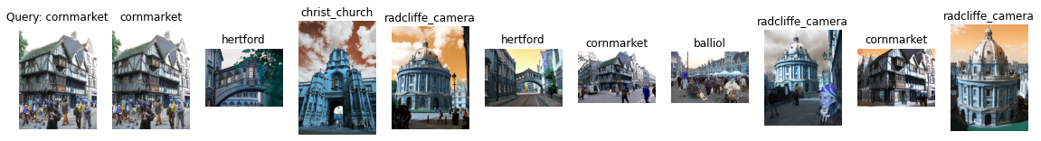

Label: cornmarket

Average Precision for query 25: 0.21022837851681953

Precision@k for query 25: 0.3

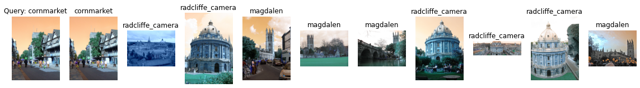

Label: cornmarket

Average Precision for query 26: 0.13543794613557228

Precision@k for query 26: 0.1

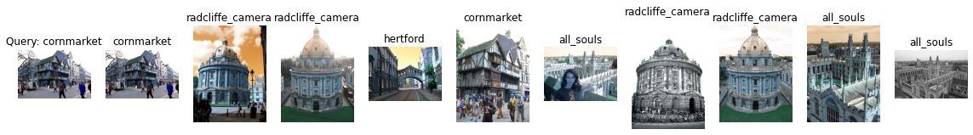

Label: cornmarket

Average Precision for query 27: 0.19053440283589862

Precision@k for query 27: 0.2

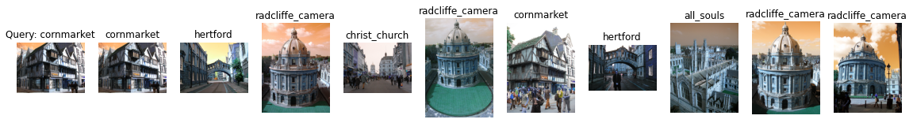

Label: cornmarket

Average Precision for query 28: 0.20394058485854513

Precision@k for query 28: 0.2

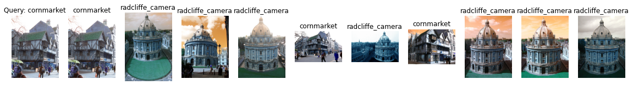

Label: cornmarket

Average Precision for query 29: 0.2339570037684534

Precision@k for query 29: 0.3

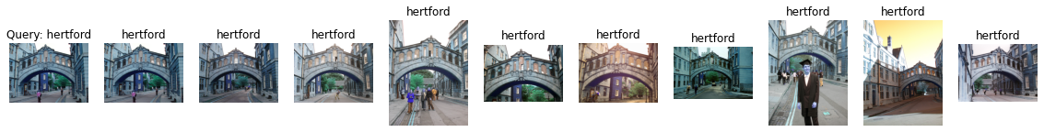

Label: hertford

Average Precision for query 30: 0.6568652040656388

Precision@k for query 30: 1.0

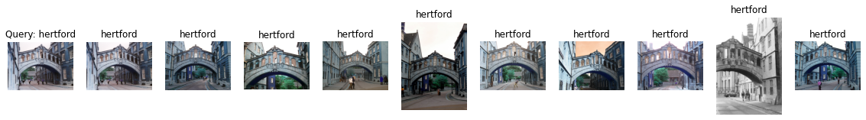

Label: hertford

Average Precision for query 31: 0.6568250680981386

Precision@k for query 31: 1.0

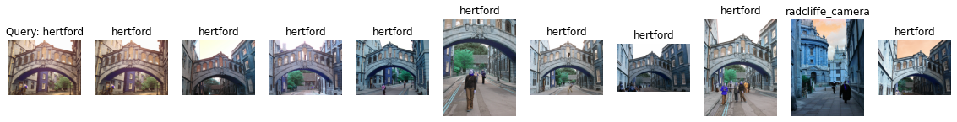

Label: hertford

Average Precision for query 32: 0.5802541480054179

Precision@k for query 32: 0.9



Label: hertford

Average Precision for query 33: 0.35614465258813965

Precision@k for query 33: 0.5

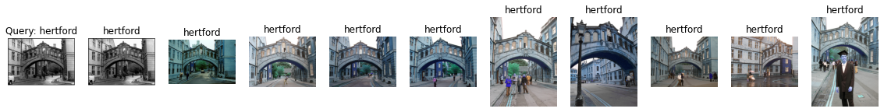

Label: hertford

Average Precision for query 34: 0.6396838836791718

Precision@k for query 34: 1.0

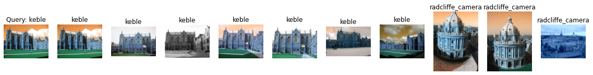

Label: keble

Average Precision for query 35: 1.0

Precision@k for query 35: 0.7

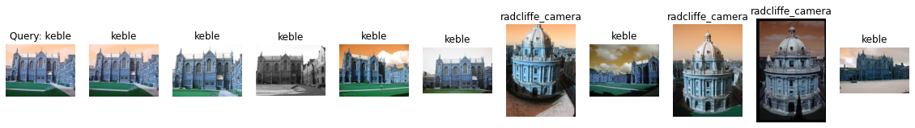

Label: keble

Average Precision for query 36: 0.936734693877551

Precision@k for query 36: 0.7

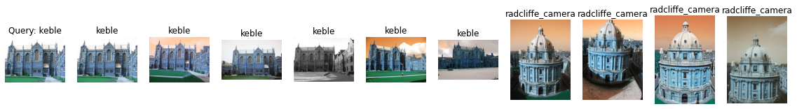

Label: keble

Average Precision for query 37: 0.9404761904761905

Precision@k for query 37: 0.6

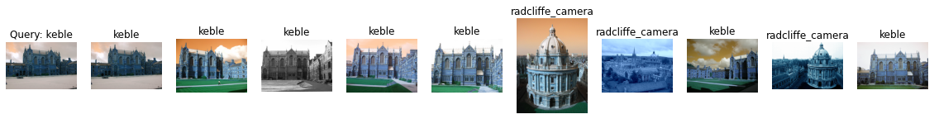

Label: keble

Average Precision for query 38: 0.9214285714285715

Precision@k for query 38: 0.7

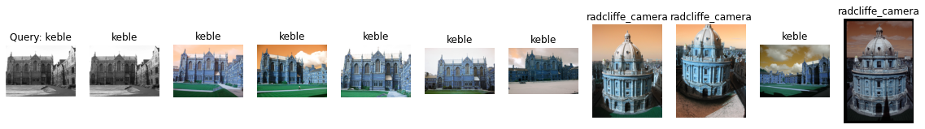

Label: keble

Average Precision for query 39: 0.9682539682539683

Precision@k for query 39: 0.7

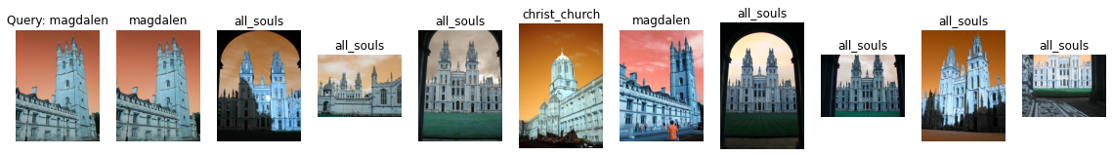

Label: magdalen

Average Precision for query 40: 0.0822923056160617

Precision@k for query 40: 0.2

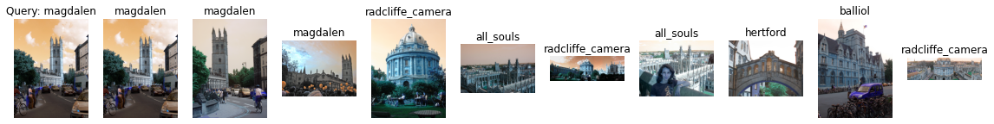

Label: magdalen

Average Precision for query 41: 0.23510494203840412

Precision@k for query 41: 0.3



Label: magdalen

Average Precision for query 42: 0.09350380486594946

Precision@k for query 42: 0.2

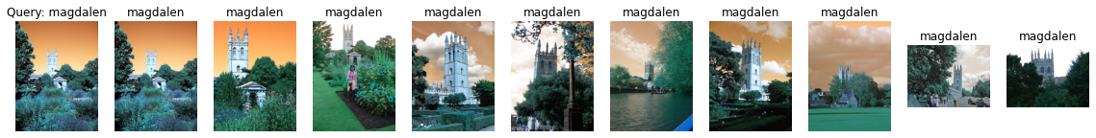

Label: magdalen

Average Precision for query 43: 0.5703680337279325

Precision@k for query 43: 1.0



Label: magdalen

Average Precision for query 44: 0.08772347917762885

Precision@k for query 44: 0.1

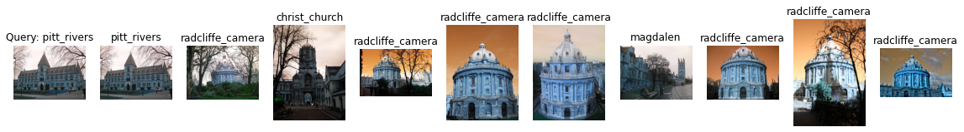

Label: pitt_rivers

Average Precision for query 45: 0.18574981187776052

Precision@k for query 45: 0.1

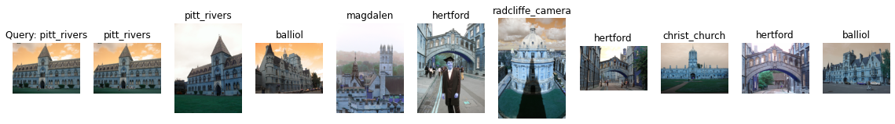

Label: pitt_rivers

Average Precision for query 46: 0.34399691623035505

Precision@k for query 46: 0.2

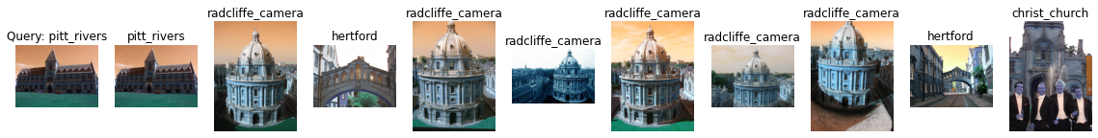

Label: pitt_rivers

Average Precision for query 47: 0.1760868486413193

Precision@k for query 47: 0.1

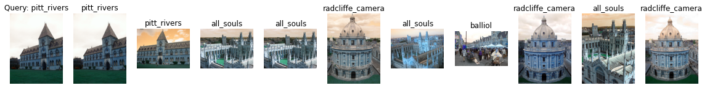

Label: pitt_rivers

Average Precision for query 48: 0.34183411857138224

Precision@k for query 48: 0.2

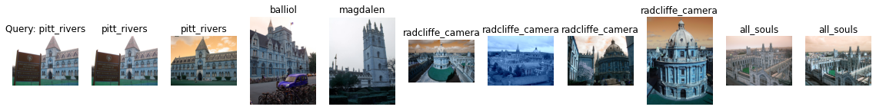

Label: pitt_rivers

Average Precision for query 49: 0.3909979757793514

Precision@k for query 49: 0.2

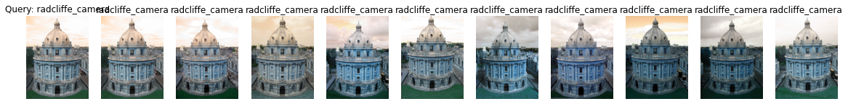

Label: radcliffe_camera

Average Precision for query 50: 0.6075758594693642

Precision@k for query 50: 1.0

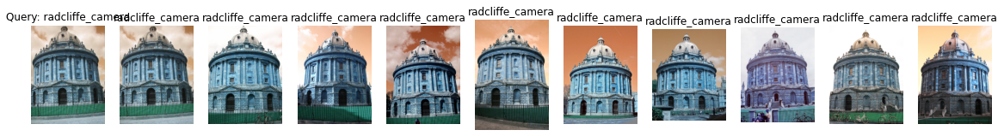

Label: radcliffe_camera

Average Precision for query 51: 0.6870755748703129

Precision@k for query 51: 1.0

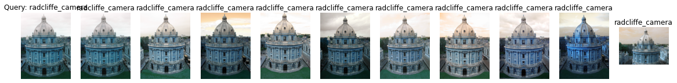

Label: radcliffe_camera

Average Precision for query 52: 0.6762959860749689

Precision@k for query 52: 1.0

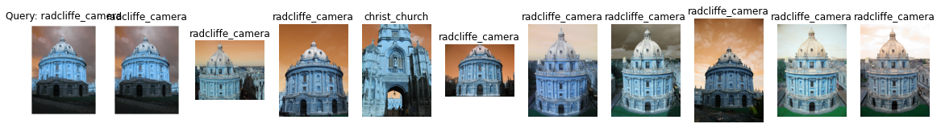

Label: radcliffe_camera

Average Precision for query 53: 0.5936927113434831

Precision@k for query 53: 0.9

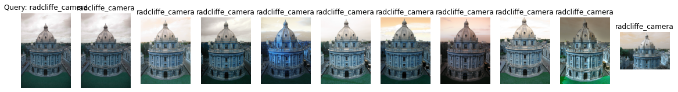

Label: radcliffe_camera

Average Precision for query 54: 0.6700292096512678

Precision@k for query 54: 1.0

mAP = 0.3843568953581918